1. Create project like the following figure:

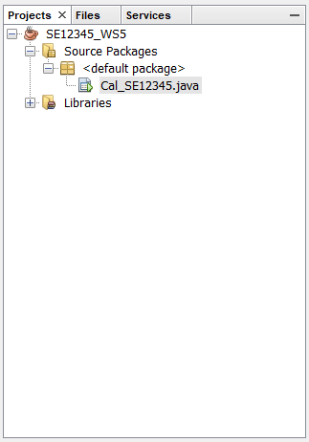

1. Design the GUI like the following figure**(10 marks)**

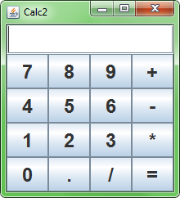

Performance requirements:

Write code that performs user-selected operations.